# Dustin Smith

# CS 255 System Design Document Template

## UML Diagrams

### UML Use Case Diagram

With the Use Case Diagram I decided to break down each case into separate sub systems for better clarity of the use case diagrams.

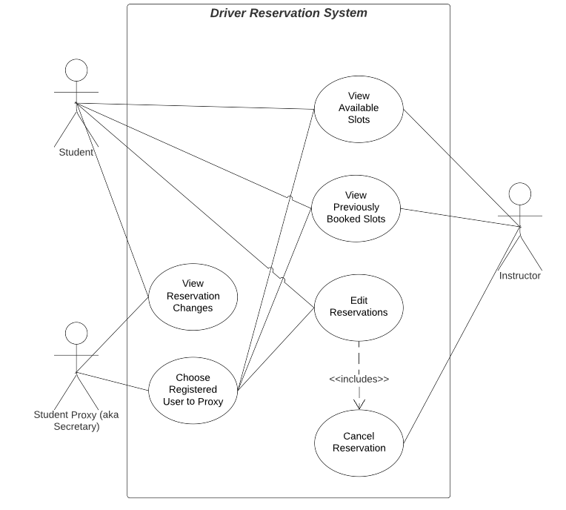

### UML Activity Diagrams

The two that I chose were for logging in to the system and then making the reservation.

### UML Sequence Diagram

For my sequence diagram I chose the use case for a user trying to login to the system.

### UML Class Diagram

The classes needed are abstract classes for user and instruction, derived classes that are for student, instructor, tests, and lessons. Finally we need vehicle and the reservations.

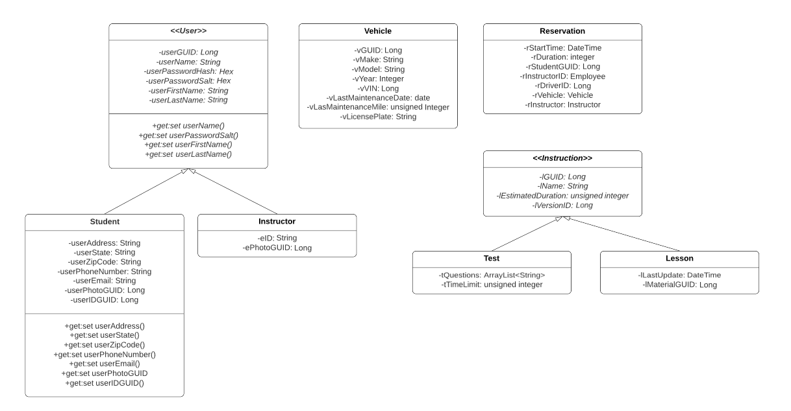

## Technical Requirements

The requirements needed are:

Linux based web server that employs IAAS 3rd party site

Scalable architecture

APIs that use RESTful techniques

Should perform SCORM standard

Hybrid approach that is of RSA encrypted AES public keys for encryption

Router traffic encrypted with TSL 1.2 or greater

All pages compliant with PWA standard

All pages tested and compatible with Samsung and iPhone technology

All pages tested and compatible with Chrome

Up time KPI no less than 99.5%

Report export will be CSV type